DAY-5

CLASSWORK

ERROR HANDLING

CODE:

import React from 'react';

const MyComponent = () => {

  const myList = ['item1', 'item2', 'item3'];

  return (

    <ul>

      {myList.map((item, index) => (

        <li key={index}>{item}</li>

      ))}

    </ul>

  );

};

export default MyComponent;

OUTPUT:

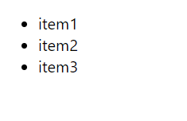

WITH ERROR MSG:

import React from 'react';

const MyComponent = () => {

  const myList = ['item1', 'item2', 'item3'];

  return (

    <ul>

      {myList.map((item) => (

        <li>{item}</li>

      ))}

    </ul>

  );

};

export default MyComponent;

OUTPUT:

ERROR . Please Check Your Input !